CS Bridge Module 18 Stacks & Queues

1. Stacks and Queues

1.1 Title Slide
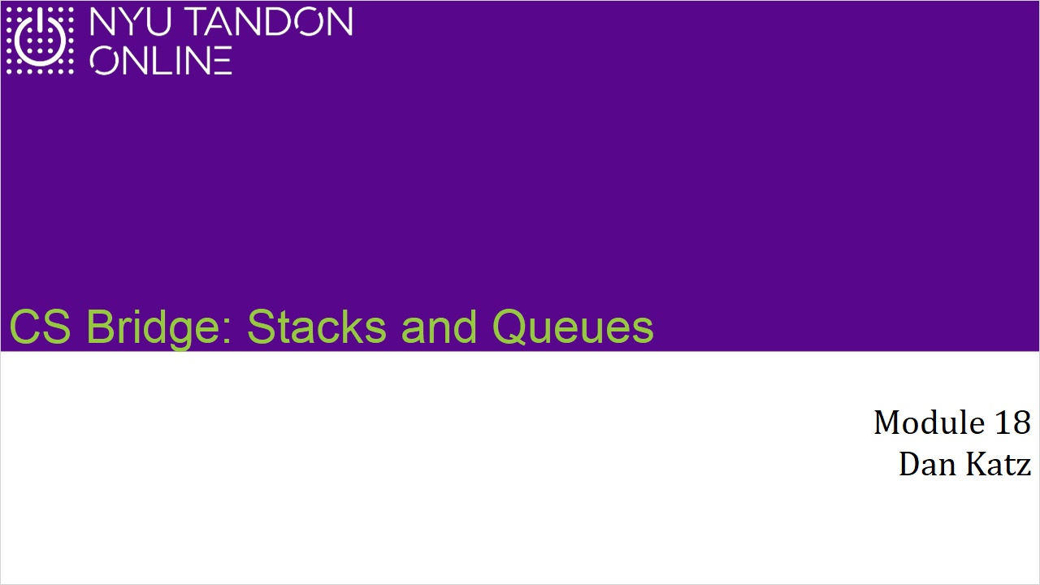
Notes:

1.2 Stacks and Queues - Intro
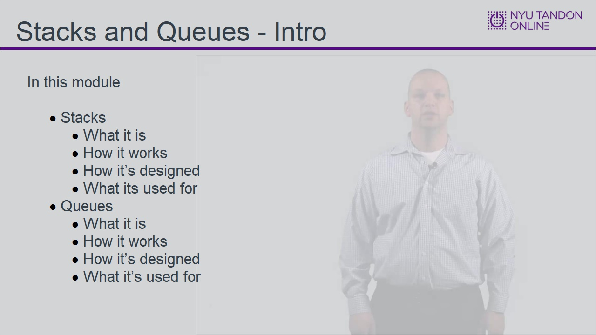
Notes:

1.3 Stack
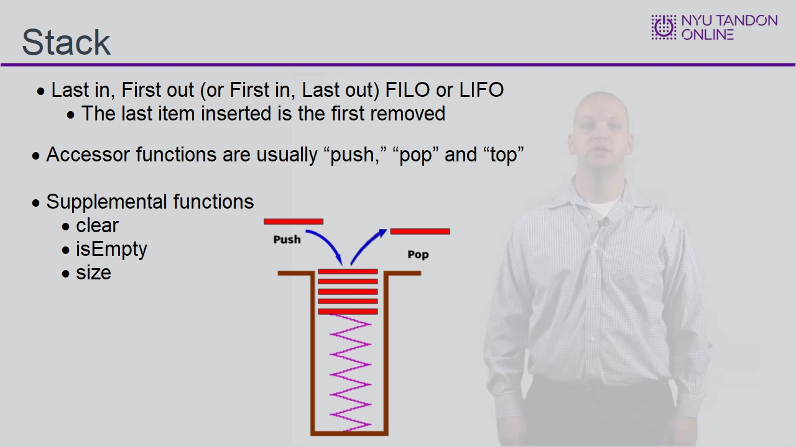

1.4 Stack, How It Works
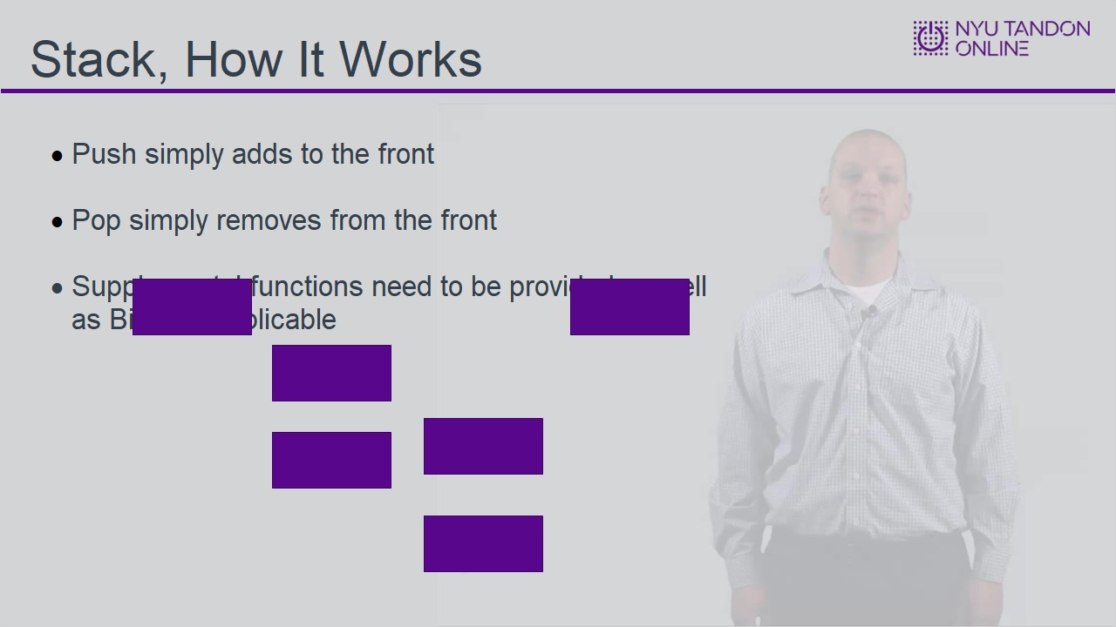

1.5 Stack Storage
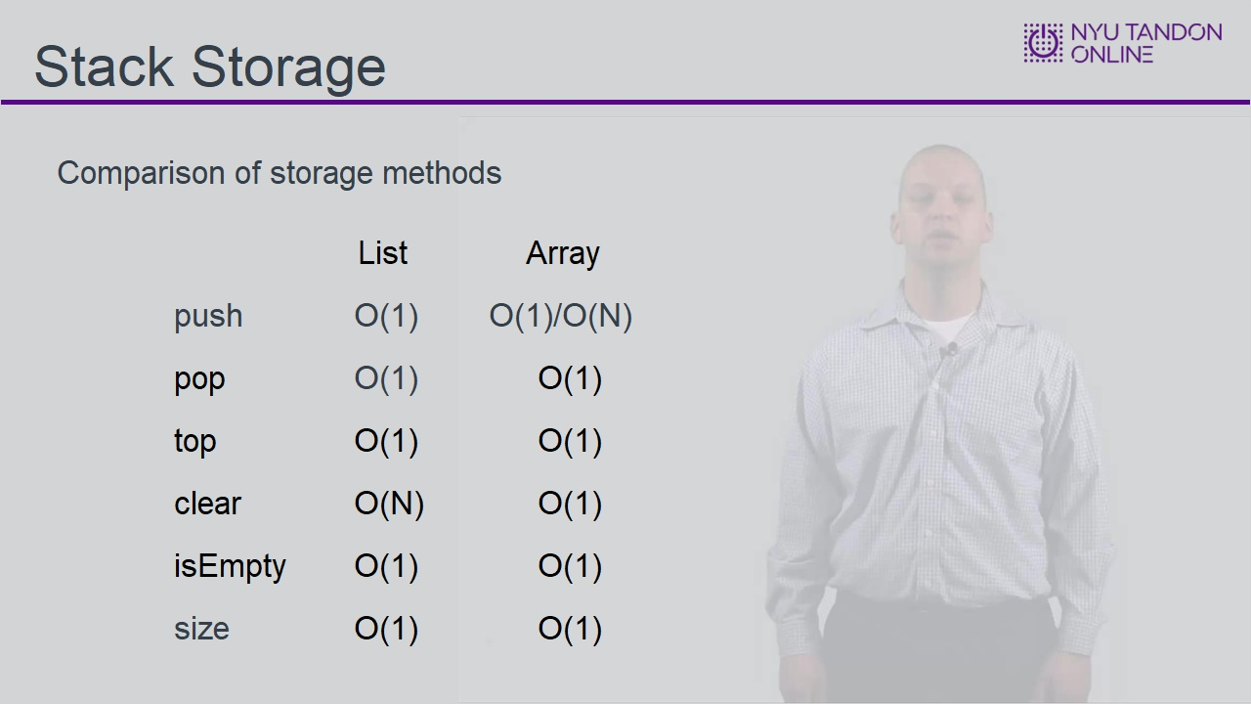

1.6 Stack Storage - Continued
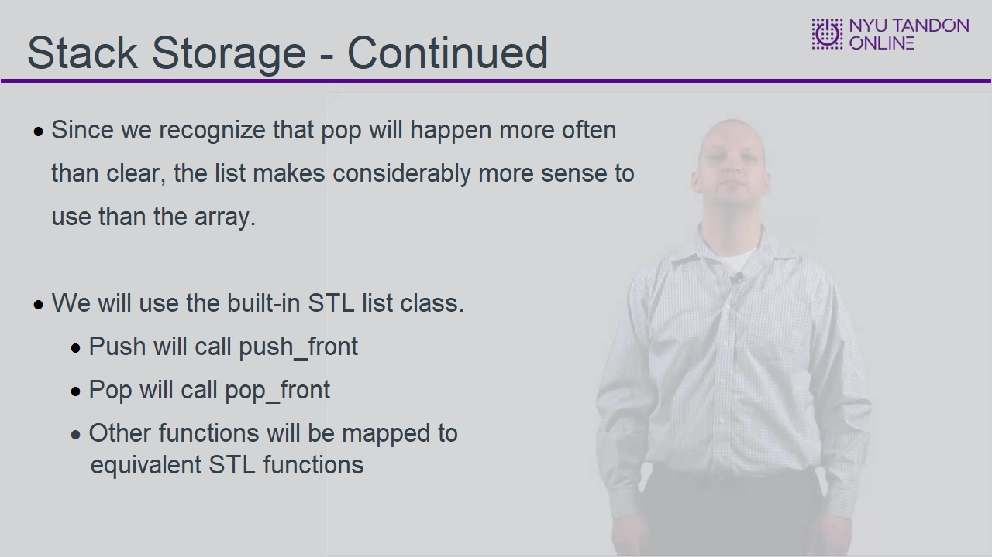

1.7 Stack Code
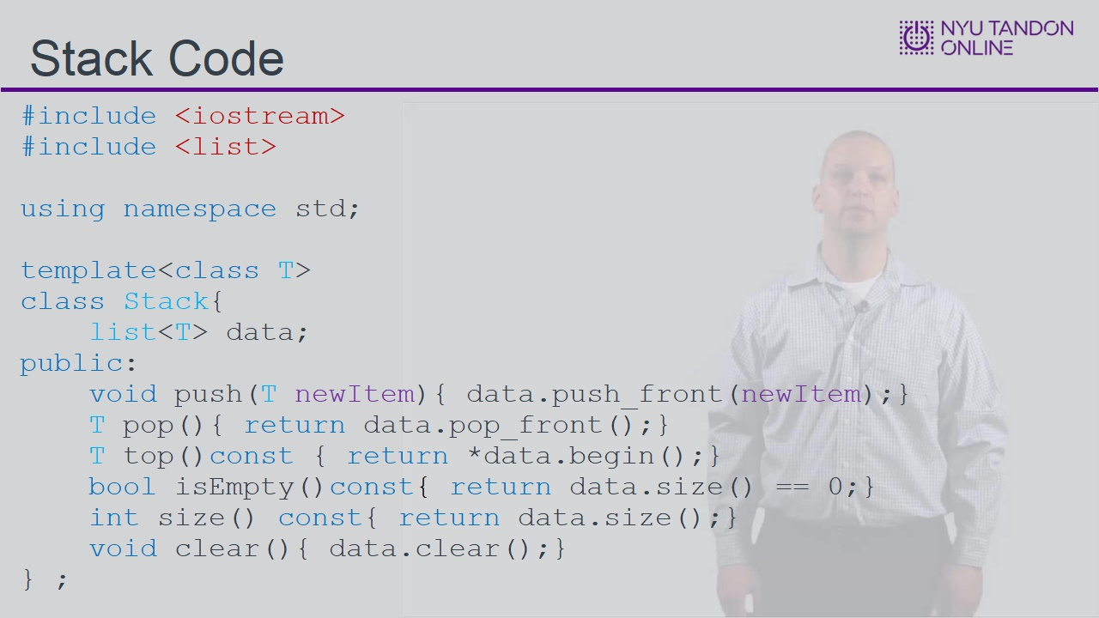

1.8 Stack, What Is It Used For
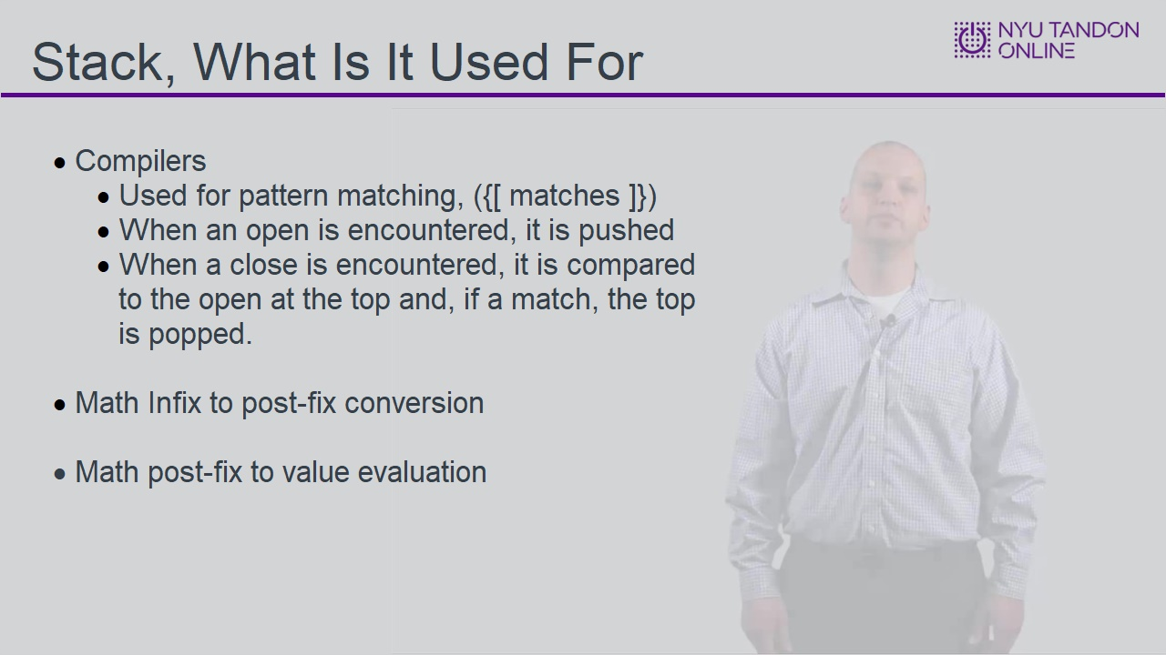

1.9 Stack, What Is It Used For
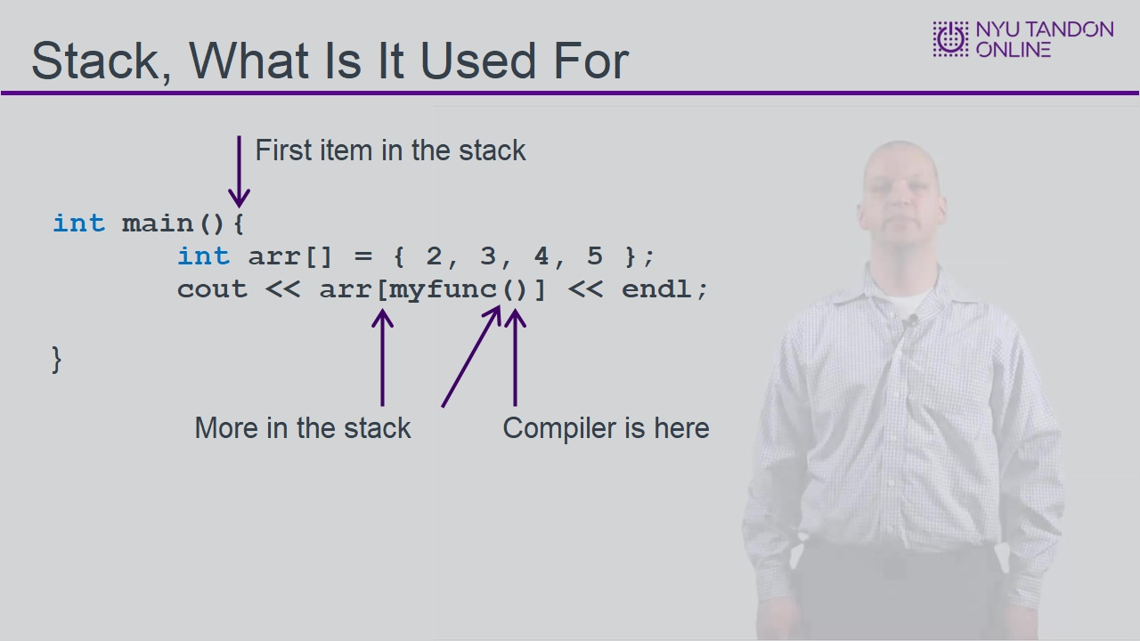

1.10 Order of Insertions
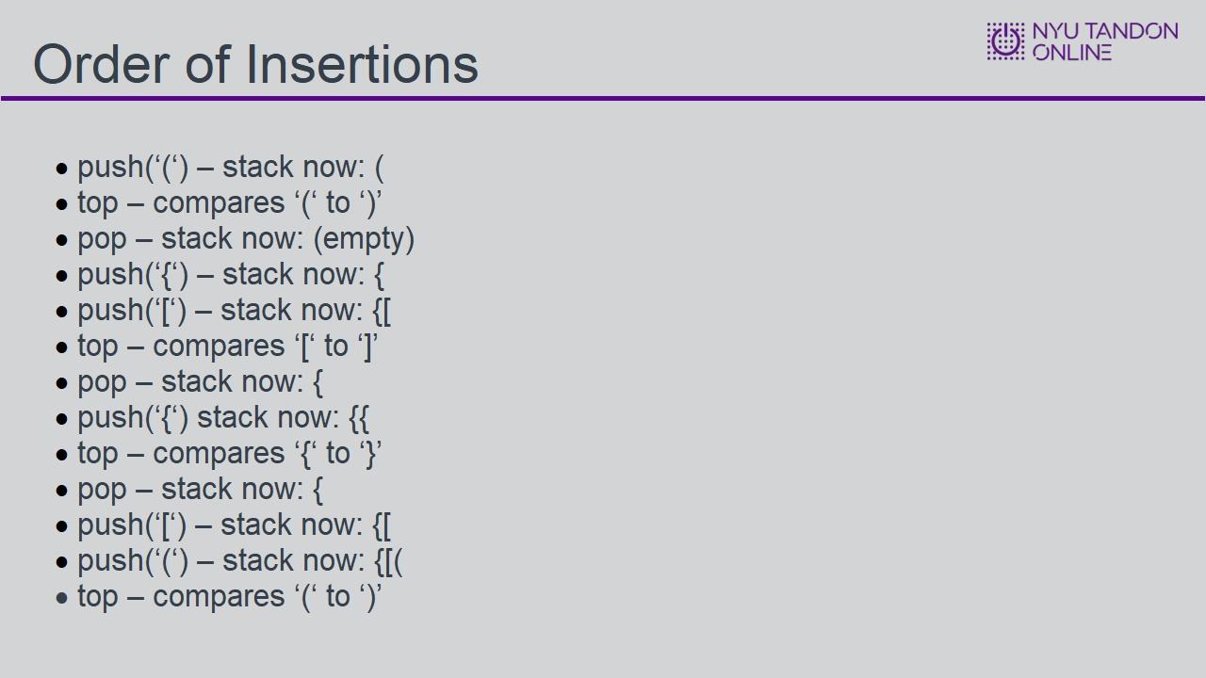

1.11 Queue, What Is It
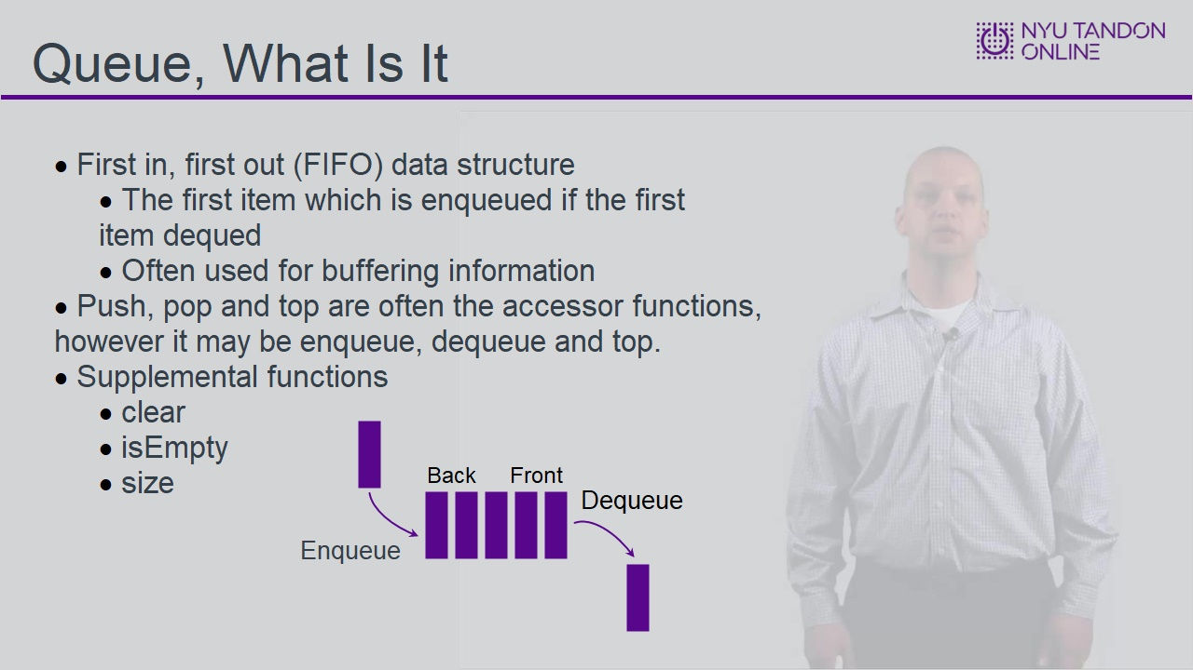

1.12 Queue, How It Works
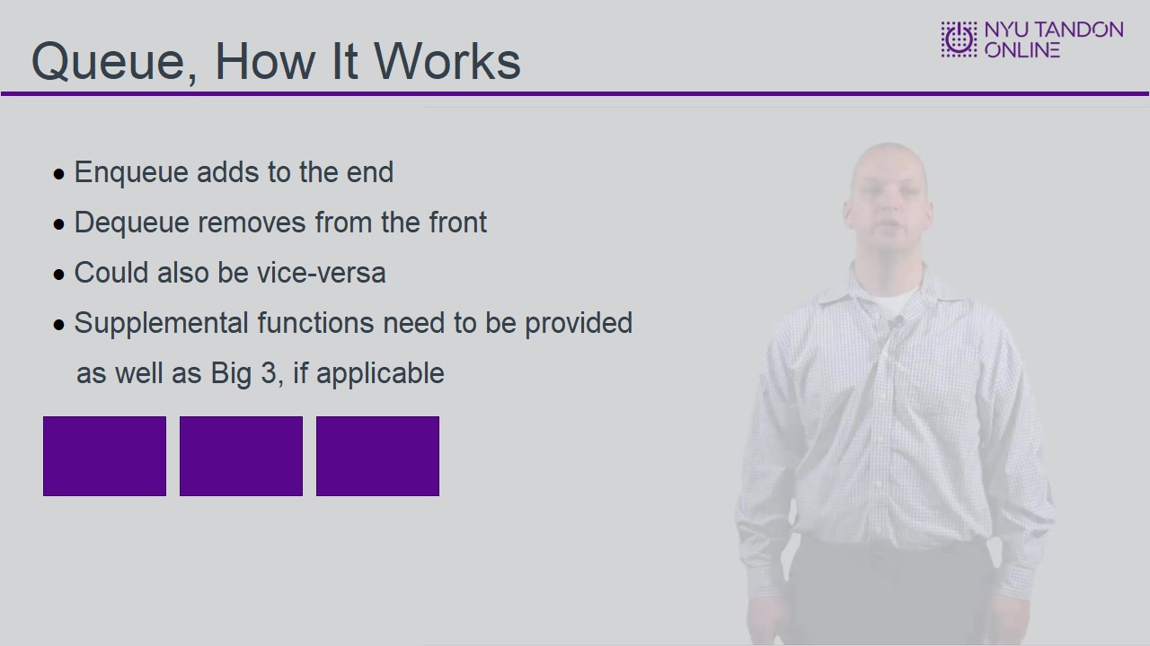

1.13 Queue Storage
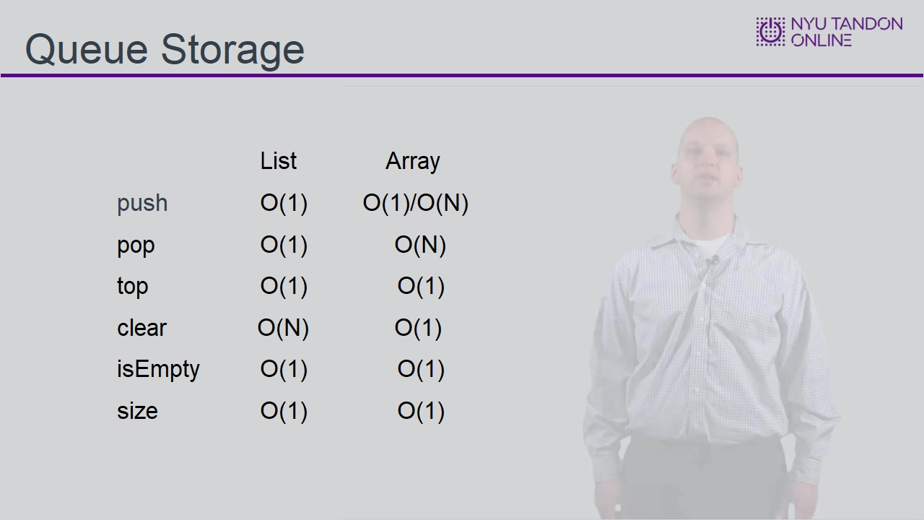

1.14 Knolwedge Check
(Multiple Choice, 10 points, 1 attempt permitted)
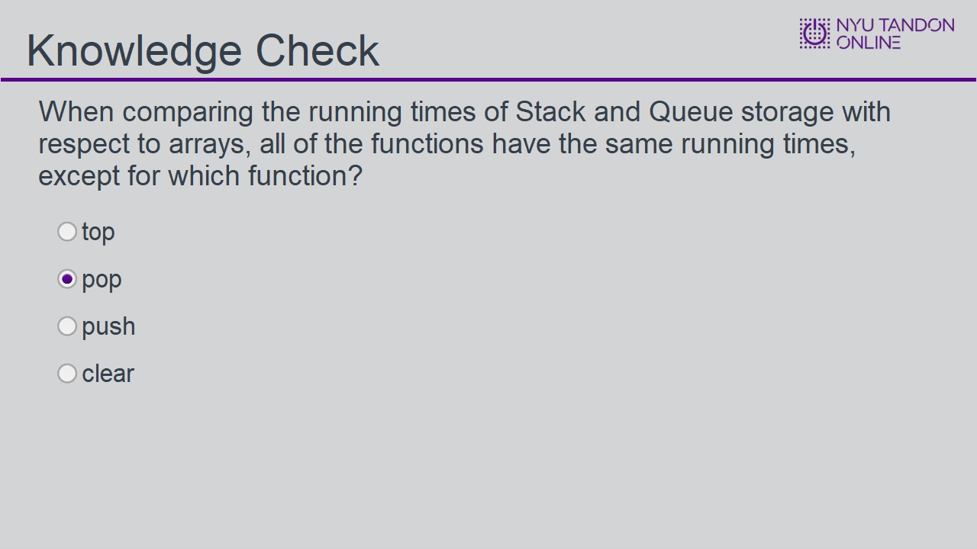
Correct | Choice
 | top
X | pop
 | push
 | clear
Feedback when correct:
That's right! You selected the correct response.
Feedback when incorrect:
You did not select the correct response.

Correct (Slide Layer)
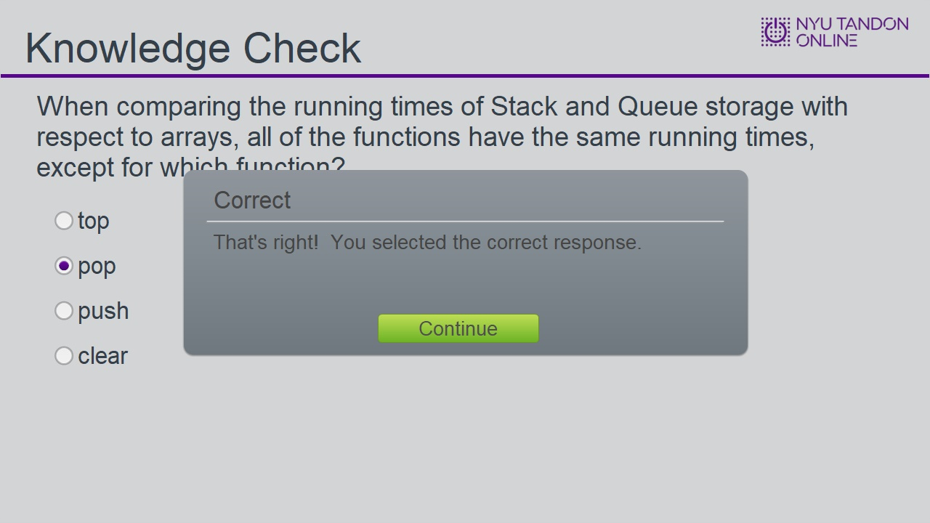

Incorrect (Slide Layer)
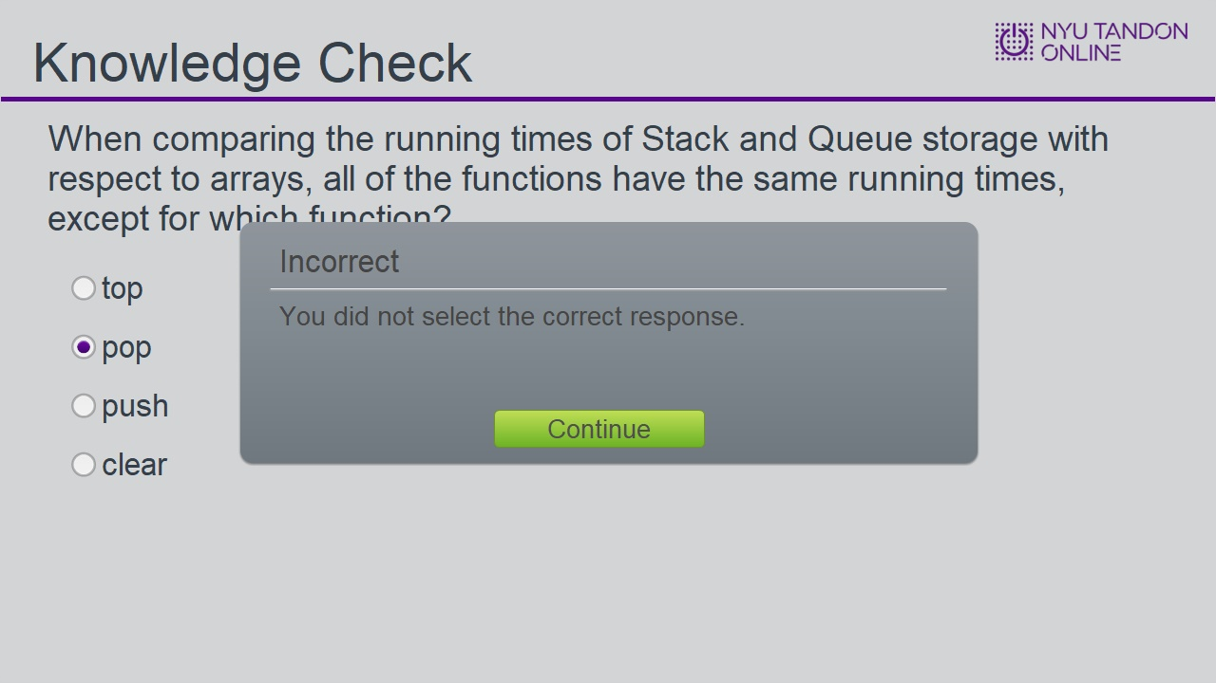

1.15 Queue - Continued
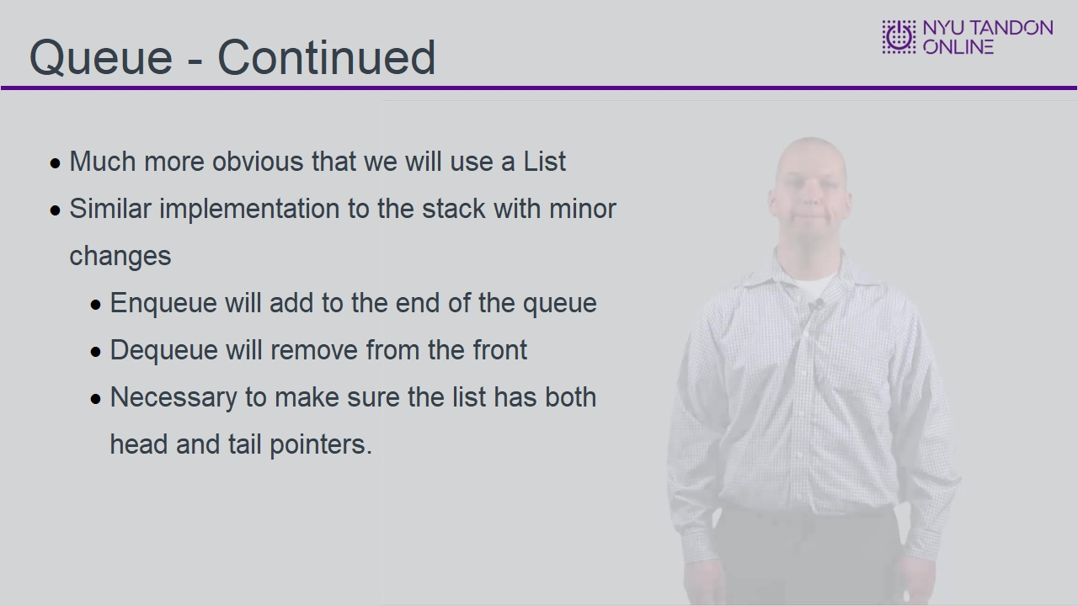

1.16 Queue Code
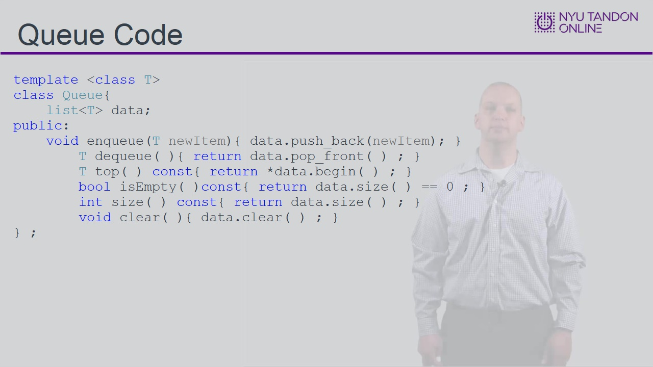

1.17 Queue, What Is It Used For
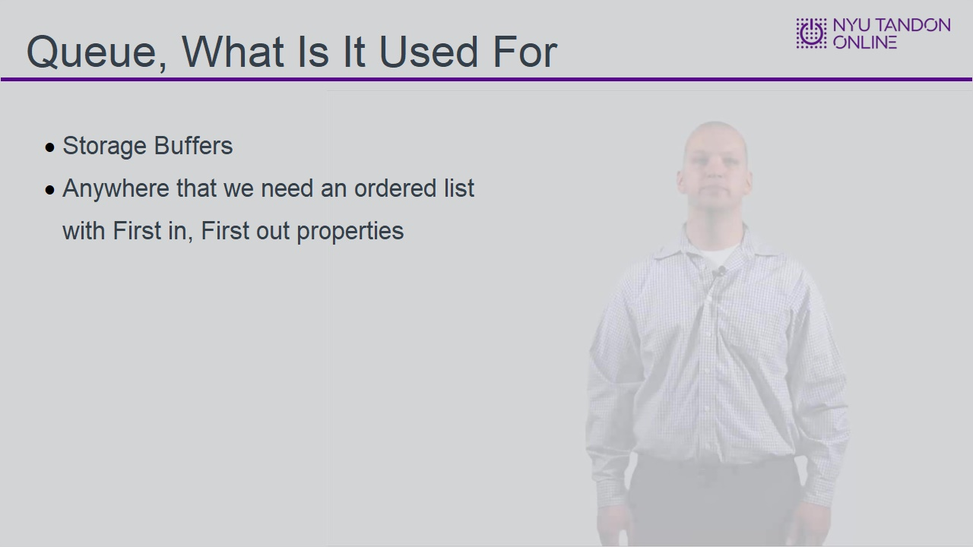

1.18 Queue Image
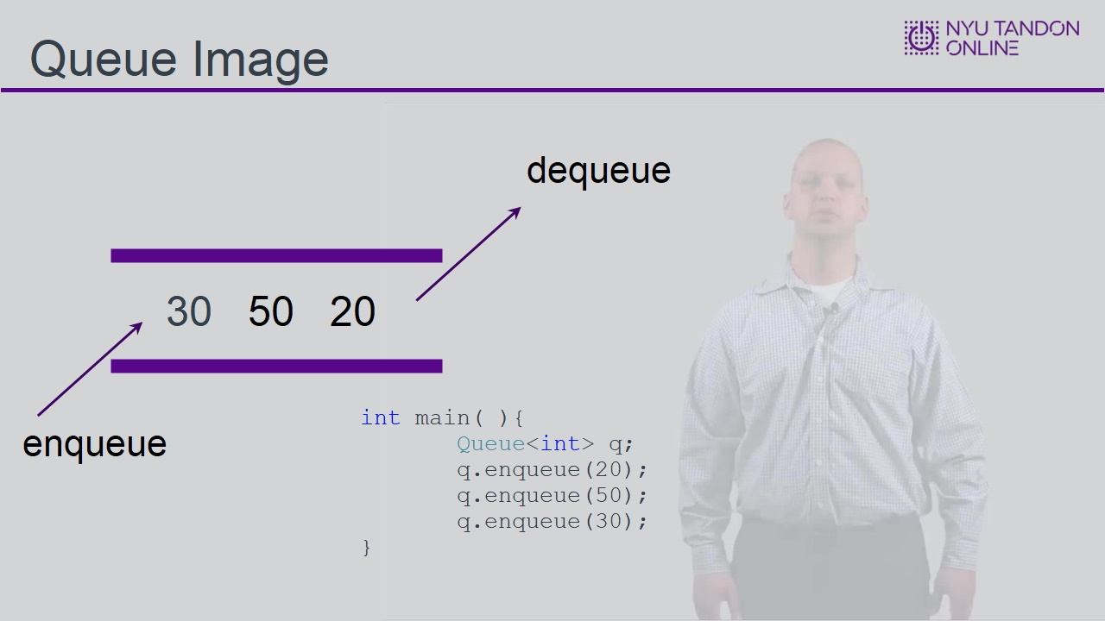

1.19 Stacks and Queues - Conclusion
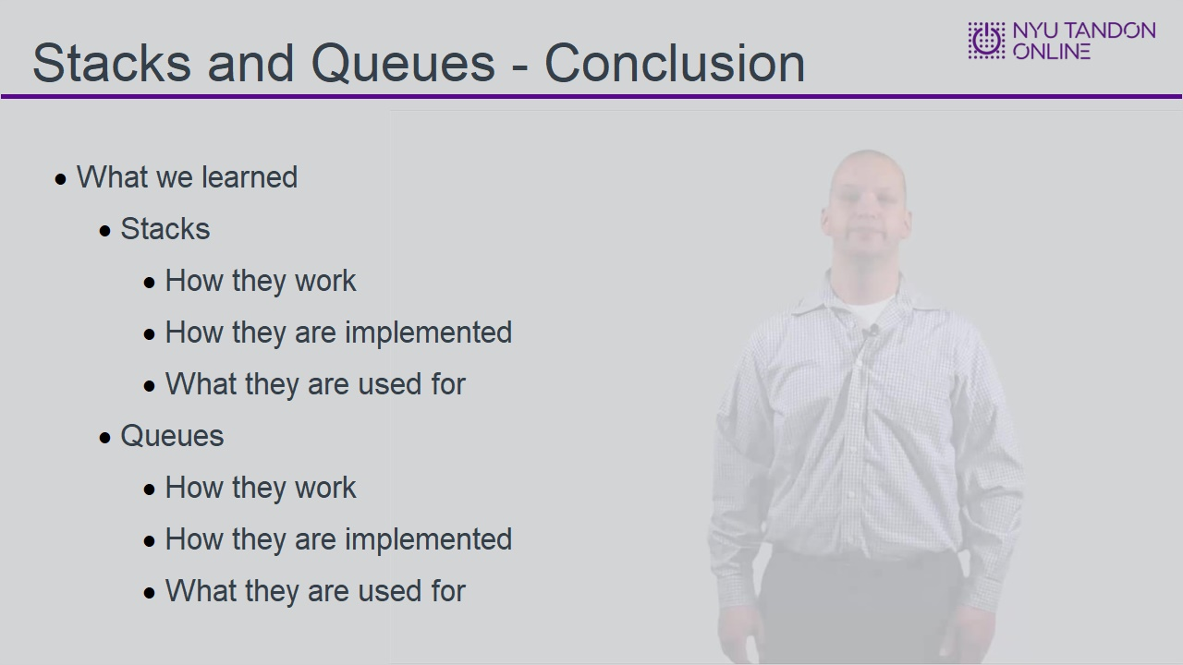

1.20 Knowledge Check
(Hotspot, 10 points, 4 attempts permitted)
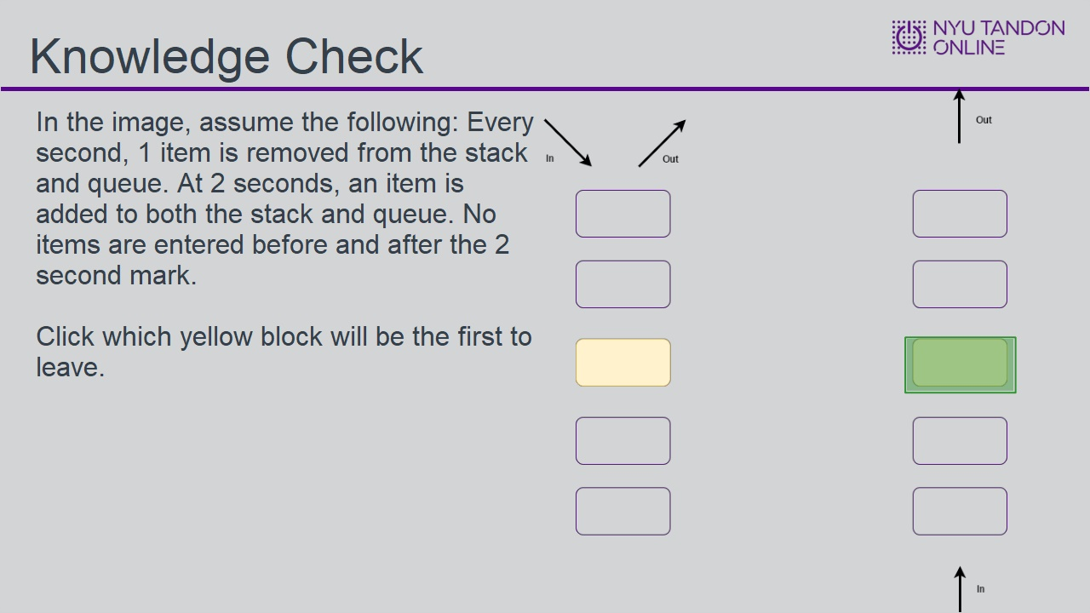
Feedback when correct:
That's right! You selected the correct response.
Feedback when incorrect:
You did not select the correct response.

Correct (Slide Layer)
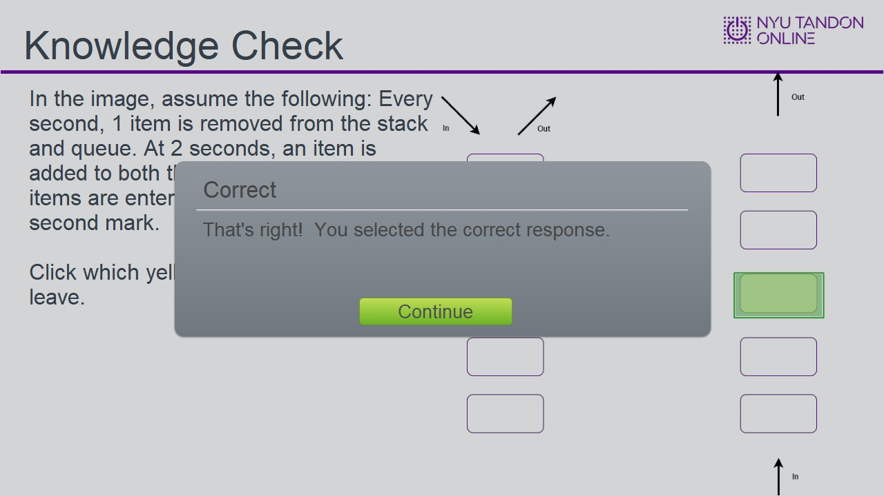

Incorrect (Slide Layer)
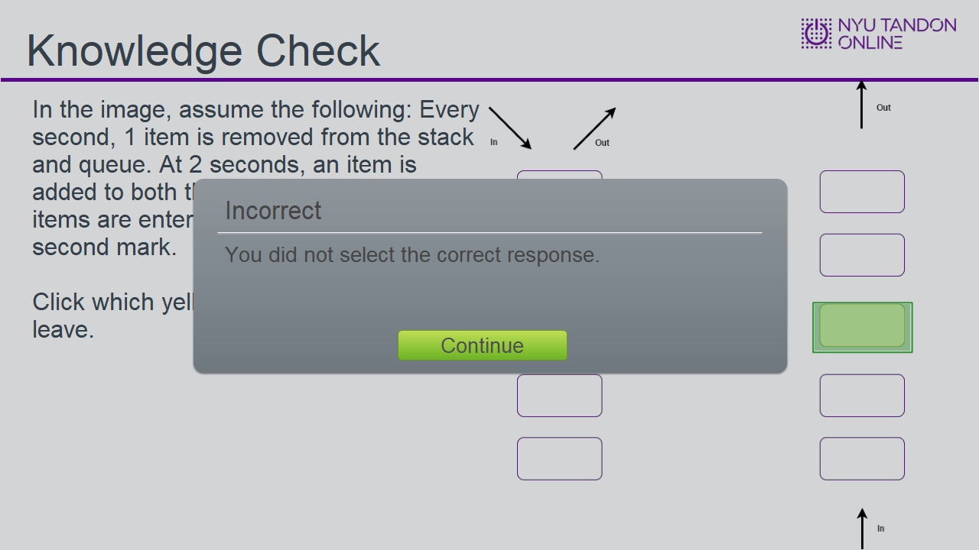

Try Again (Slide Layer)
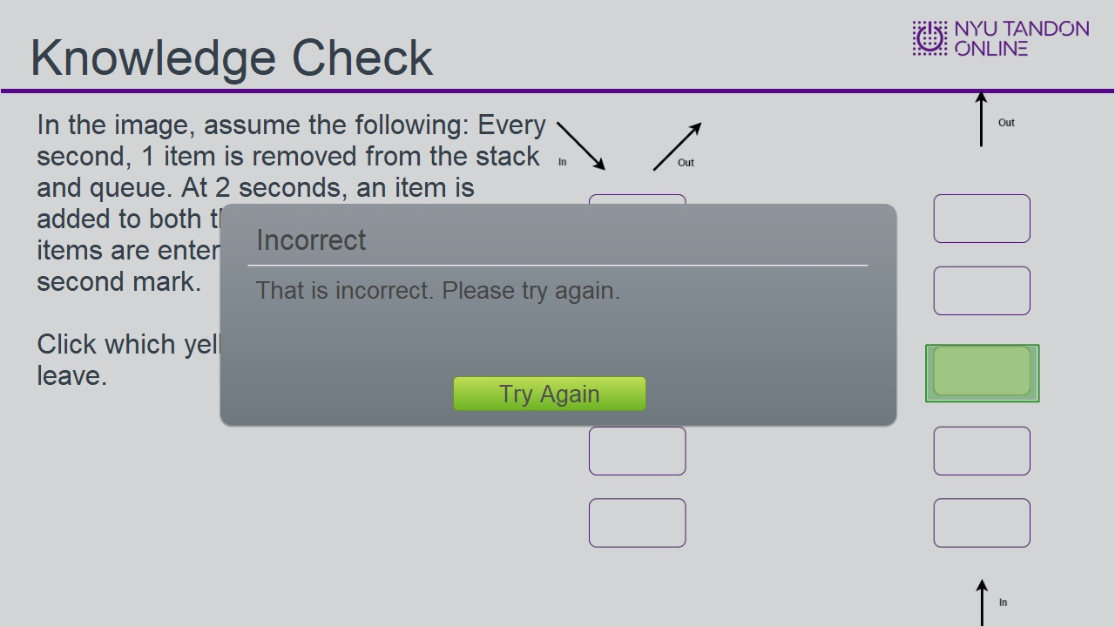

1.21 End of Module
